**HealthCare Web Portal**

“**Mini Project Based on Web Application**”

By

# Sohan Sakhare (Roll No.: 59)

1. **Kaustubh Patil(Roll No.: 47)**

# Antima Yadav(Roll No.: 68 )

Class

# TE

Project Domain

# HealthCare Web Portal



Department of Information Technology Pillai HOC College of Engineering & Technology

# 2022-2023

**CERTIFICATE**

This is to certify that the project entitled **HealthCare Web Portal** from is a bonafide work Of **Sohan Sakhare, Kaustubh Patil & Antima Yadav** studying in **TE** which is carried under “Mini **Project Based on Web-Application**”.

--------------------- -------------------

Head of Department Project Coordinator

Dr. Divya Chirayil Ms.Rupali Sathe

----------------- -----------------

Internal Examiner External Examiner

# Project Report Approval

This project report entitled **HealthCare Web Portal** from **domain name Using Web Application** by **Sohan Sakhare, Kaustubh Patil & Antima Yadav** studying in **TE** has been approved which is carried under “ **Mini Project Based on Web Application**”.

Mini Project Guide Name & signature



Ms. Rupali Sathe

Date:

Place: Rasayani , Panvel

# Declaration

I declare that this written submission represents my ideas in my own words and where others’ ideas or words have been included, I have adequately cited them and referenced the original sources. I also declare that I have adhered to the principles of academic honesty and integrity and have not misrepresented or fabricated or falsified any idea/data/fact/source in my submission. I understand that any violation of the above will cause disciplinary action by the institute and can also evoke penal action from the sources which have thus not been properly cited or from whom proper permission has not been taken when needed.



--------------------------- ---------------------------- ---------------------------

Antima Yadav Kaustubh Patil Sohan Sakhare

# 

**Acknowledgement**

It is a privilege for us to have been associated with **Ms. Rupali Sathe**, our guide, during this project work. We have been greatly benefited by his valuable suggestions and ideas. It is with great pleasure that we express our deep sense of gratitude to them for their valuable guidance, constant encouragement and patience throughout this work.

I am also indebted to **Dr. Divya Chirayil** (Head of Department of Information Technology), **Ms. Rupali Sathe** (Mini Project Guide) for extending the help to academic literature.

We express our gratitude to **Dr. J.W.Bakal** (Principal) for their constant encouragement, co-operation and support.

We take this opportunity to thank all our classmates for their company during the course work and for the useful discussion we had with them. We would be failing in our duties if we do not make a mention of our family members including our parents for providing moral support, without which this work would not have been completed.

Submitted By

Kautubh Patil

Sohan Sakhare

Antima Yadav

**INDEX**

| **Sr.No.** | **Content** | **Page no** |
| --- | --- | --- |
| 1. | Introduction | 7 |
| 1.1 | Purpose | 7 |
| 1.2 | Problem Statement | 8 |
| 1.3 | Scope | 8 |
| 1.4 | Overview | 8 |
| 1.5 | Objective | 9 |
| 2. | ER- Diagram | 10 |
| 3. | Data Flow Diagram | 11 |
| 4. | Working | 12 |
| 5. | Requirement Analysis | 12 |
| 6. | Code | 13 |
| 7. | Outputs | 15 |
| 8. | Conclusion | 17 |
| 9. | Reference | 18 |

1. **Introduction**

There is an increased interest in the adoption of e-healthcare solutions and the fundamental change on how patient records, service provider communications, and appointment scheduling can be delivered.

An e-Health portal is a secure online web portal that gives patients convenient, 24-hour access to personal health information from anywhere via an Internet connection, often “tethered” to their integrated electronic health records.

e-Health portals save the patient time, also keep them organized, up to date, and deliver a higher overall level of convenience.

Our project web portal for health care is developed so that the patient can know their consultant on their own and also choose the best one.

It fills the gap between patient and the service provider.

**1.1 Purpose**

Purpose of web health care portal is to provide a way to the customers to by providing

the health services.

* A patient portal is a secure online website that gives patients convenient,
* 24-hour access to personal health information from anywhere with an Internet connection.
* Using a secure username and passwordRecent doctor visits
* Patients can view health information such as Medications.
  1. **Problem Statements**
* No Remote Access.
* Existing siloes in the healthcare world.
* Issue with Medicare and Medicaid Reimbursement.
* Absence of supply management system.
* Managing massive volumes of patient related data.

**1.3 Scope**

The scope for healthcare services and solutions can prove to be a game changer in the patient care space. And in the current urban milieu where internet access is far higher than the national average; the number of potential consumers especially from the corporate sector, provides an untapped opportunity for healthcare providers to pilot, facilitate, regulate, and expand the span of preventive medicine, primary health care, and wellness programs beyond conventional boundaries.

**1.4 Overview**

An online health care web portal simplifies the task of the user to get remote access to a health website. The website provides the patient to take a health test for the home itself .It gives 24/7 services to the people and also the service like .

Its is some that allow to contact and all other priorities thing

**1.5 Objectives**

Web health care portals continue to grow the flexibility and performance abilities of these remote-oriented platforms. To create a reliable experience for medical experts to provide quality care and advice to patients from miles away.

Doctors can focus more on their core functionalities and offer effective coordinate care with other doctors to plan cohesive, personalized treatment plans.

These solutions provide healthcare professionals with real-time access to patient-related data like registrations, medical history, diagnoses, treatments, and more.

1. **E-R Diagram**

 The object/relationship pair is the cornerstone of the data .These pairs are represented  graphically using E-R diagrams. A set of primary components are identified for the ERD: data objects, attributes, relationships and various type indicators. The primary purpose of ERD is to represent data objects and their relationships.

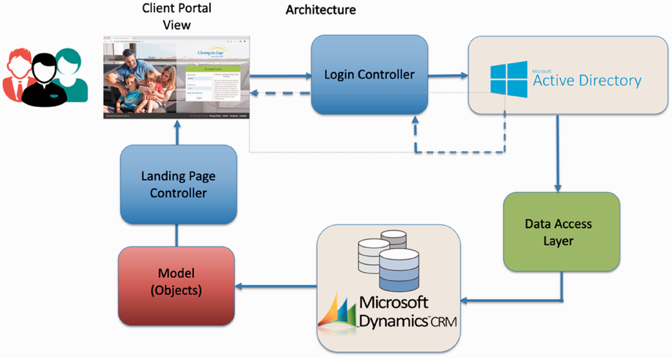

1. **System Flow/Data Flow Diagram**

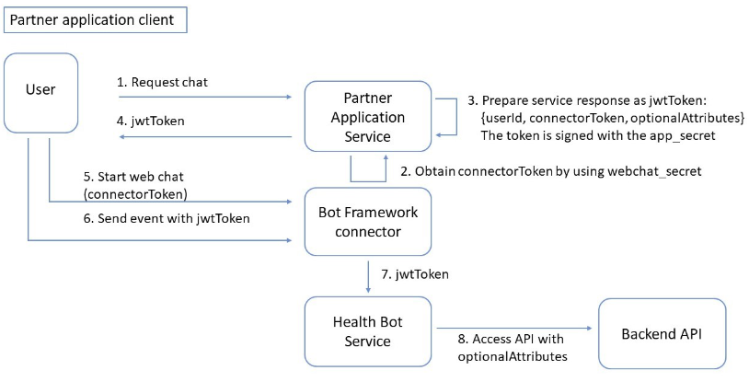

# Working





# 

# Requirement Analysis

**Software Requirements**

Operating System : Windows 11

User Interface : HTML, CSS

Client-side Scripting : JavaScript

IDE/Workbench : VS Code

**Hardware Requirements**

Processor : Intel core i5

Hard Disk : 1TB

RAM : 8GB or more

# Code

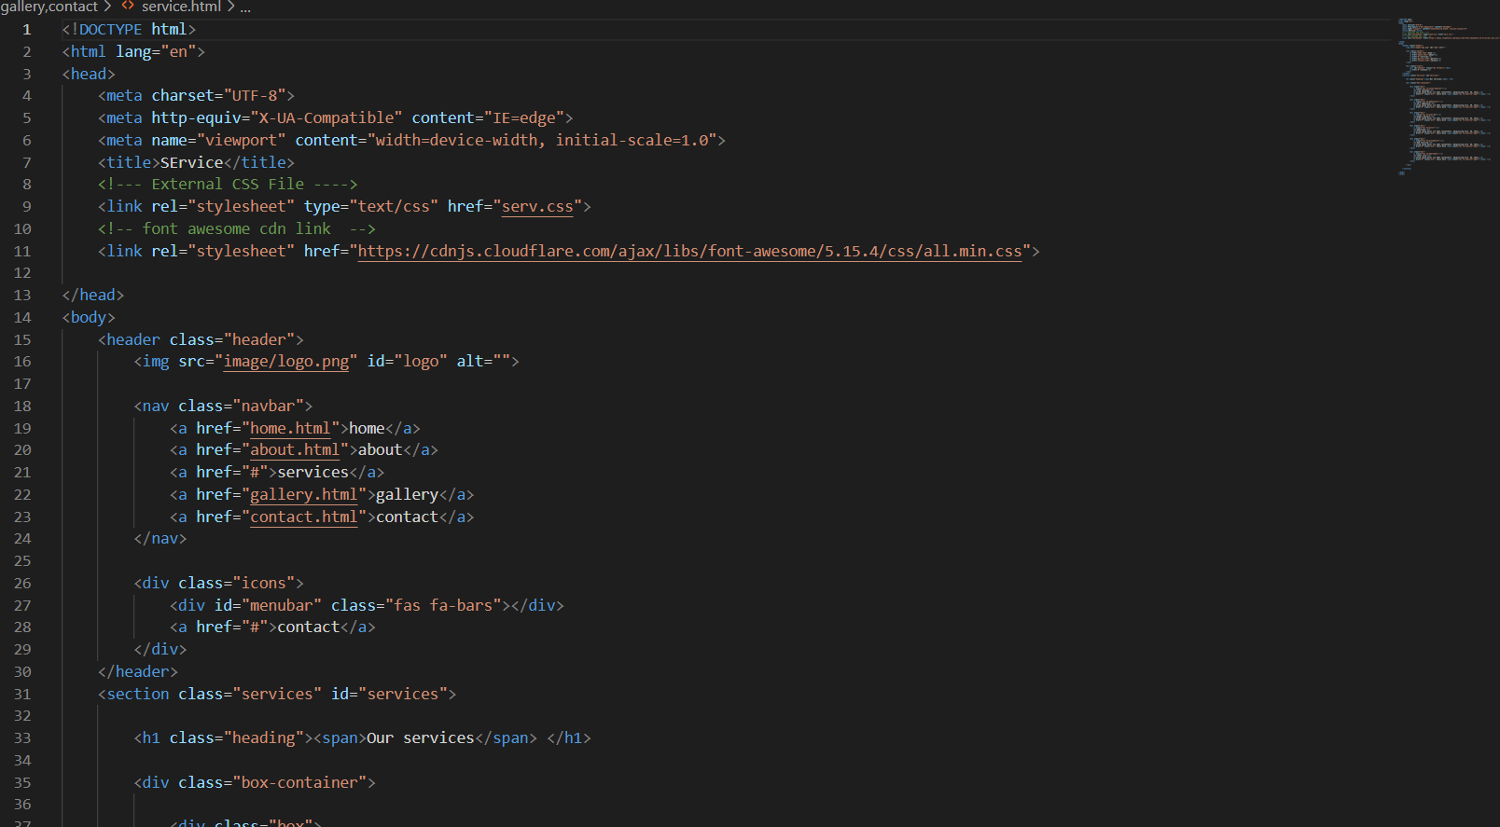

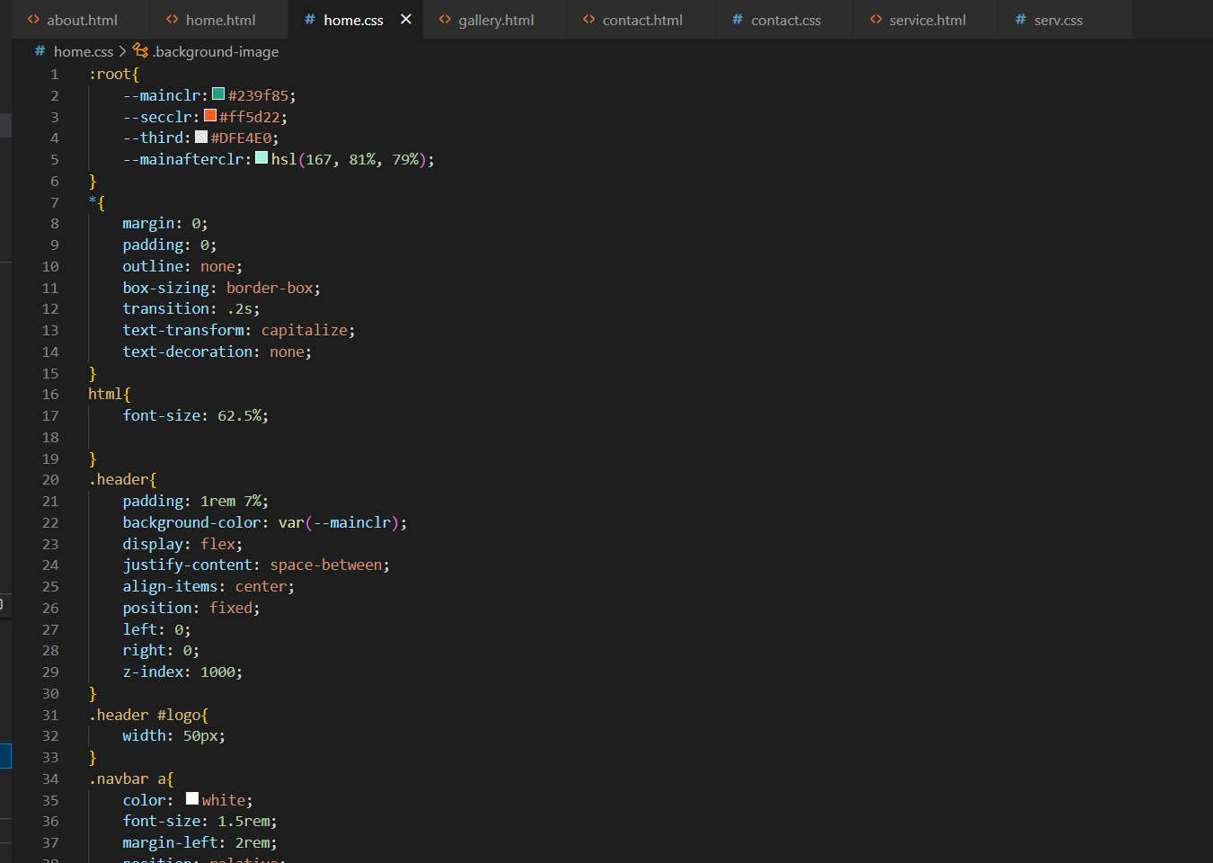

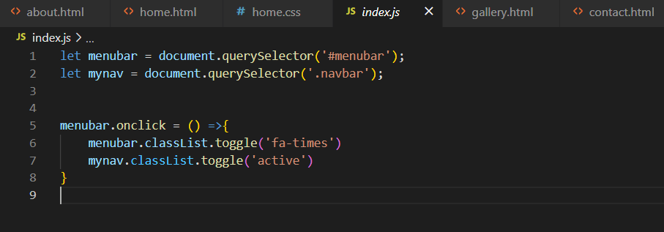

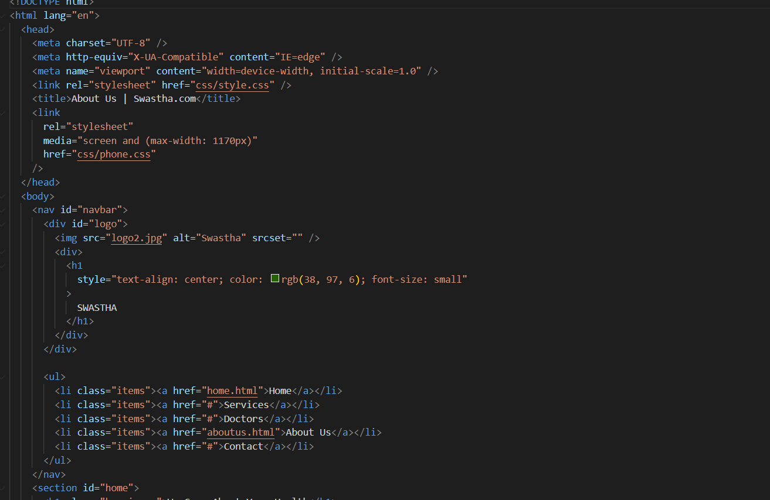

1. **Output**

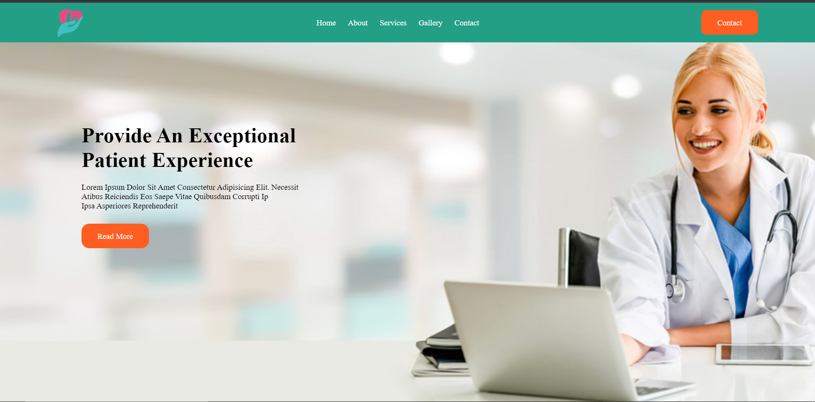

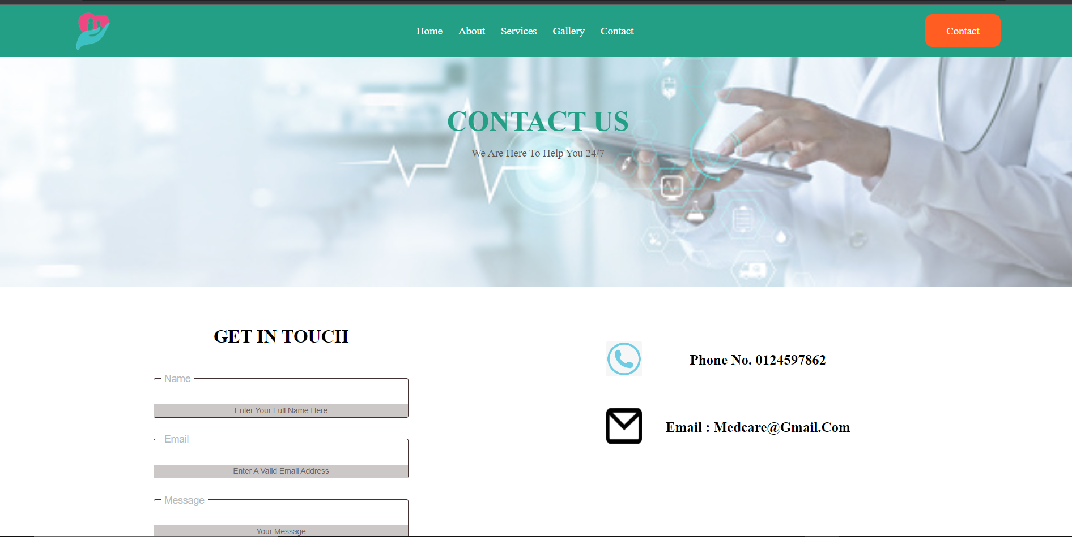

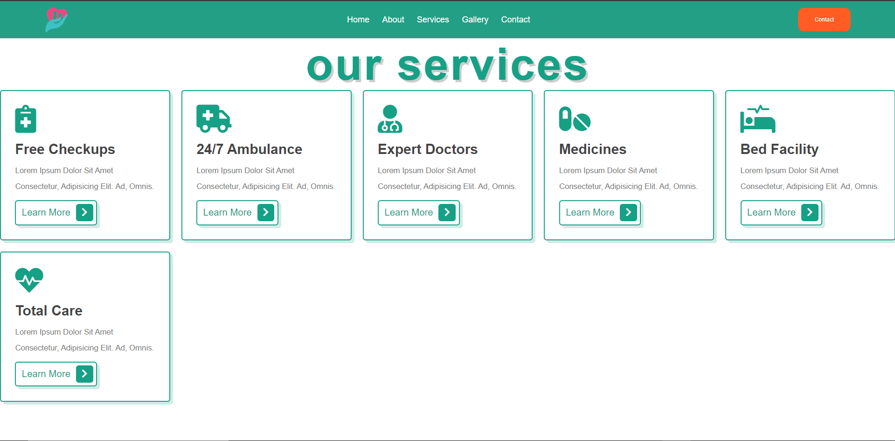

# Conclusion

There’s no denying that the healthcare industry has come a long way as technology continues to take on a role of prominence in this industry. From dealing with data overload across various institutions to connecting doctors and patients from opposite ends of the globe via Web page , healthcare technology continues to advance in the right direction.

We may presently be viewing just the tip of the iceberg in terms of what mobile apps, cloud-based services, and other digital assets have to offer to healthcare professionals. [Digital transformation in healthcare](https://www.netsolutions.com/insights/digital-transformation-in-healthcare/) is expected to be seen more prominently in the coming times and will bring exciting opportunities in the industry for doctors as well as patients.

At the end this portal will be helpful for all the people who want to be able to move from their place and those who aren't able to reach the hospital and diganos their diseases on proper time .

# Reference

HTML: Complete Reference

• www.w3schools.com

• [www.emurse.com](http://www.emurse.com)

Various e-books and tutorials provided on Internet

• www.wikipedia.org

• www.webreference.com

• www.dynamicajax.com

• www.webdesign.org

• www.csstutorial.net

• www.photoshopsupport.com

• www.learn-sql-tutorial.com

• [www.learn-xml-tutorial.com](http://www.learn-xml-tutorial.com)

